**What is Tumblr?**

Tumblr is a microblogging and social networking website founded by David Karp in 2007 and owned by Media. The service allows users to post multimedia and other content to a short-form [blog](https://en.wikipedia.org/wiki/Blog). Users can follow other users' blogs. Bloggers can also make their blogs private. Many of the website's features are accessed from a "dashboard" interface.

**Features**

**Dashboard:** The dashboard is the primary tool for the typical Tumblr user. It is a live feed of recent posts from blogs that they follow. Through the dashboard, users are able to comment, reblog, and like posts from other blogs that appear on their dashboard. The dashboard allows the user to upload text posts, images, video, quotes, or links to their blog with a click of a button displayed at the top of the dashboard.

**Queue:** Users are able to set up a schedule to delay posts that they make. They can spread their posts over several hours or even days

**Tags:** Users can help their audience find posts about certain topics by adding tags.

**HTML editing:** Tumblr allows users to edit their blog's theme HTML coding to control the appearance of their blog.

**Mobile Apps:** Other than website app for Android, IOS, and Windows Phone is also available.

**Inbox and messaging** : On November 10, 2015, Tumblr introduced an integrated instant messaging function, allowing users to chat between other Tumblr users. The ability to send posts to others via the Dashboard was added the following month.

**How to add ads to tumblr post.**

1. Create an Account on an Advertising Platform

Visit the home page of [Google AdSense](https://www.google.com/adsense), [Bing Ads](https://bingads.microsoft.com/) or [Infolinks](http://www.infolinks.com/) -- three of the largest online advertising platforms -- and complete the account creation process. Wait for the platform to approve your account.

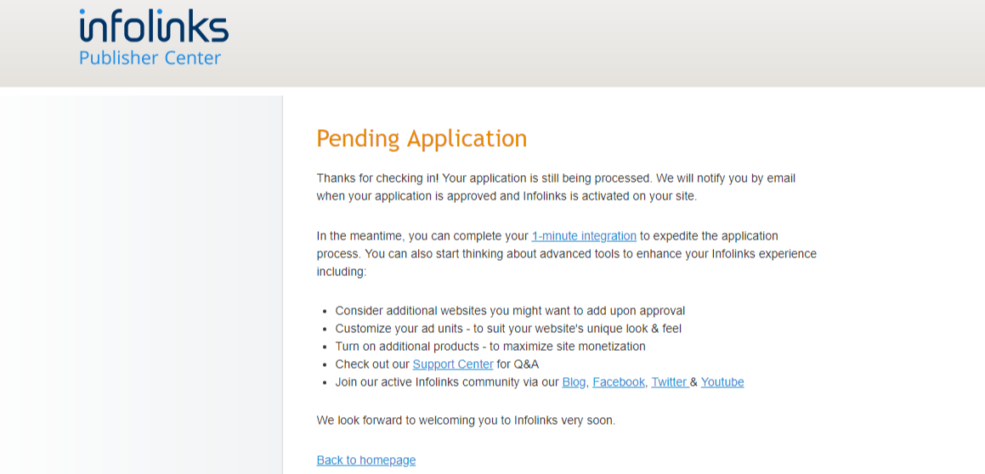

1. Copy the HTML code supplied by the platform into your Windows clipboard.

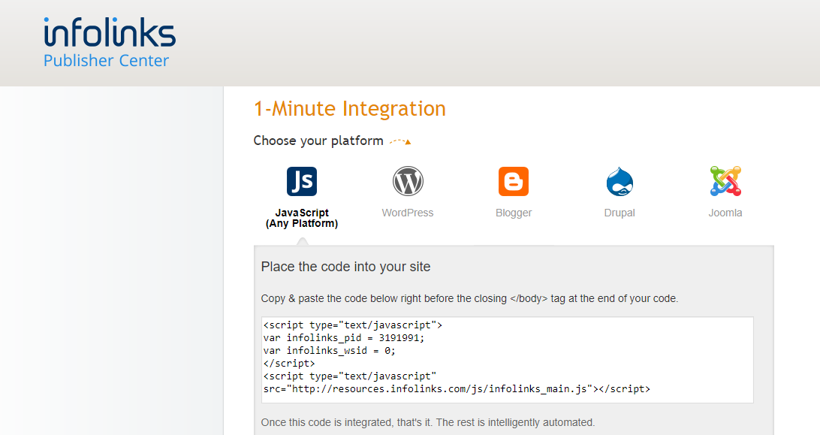

1. Paste the Code Snippet in Your Blog's HTML Code.
2. Select **Edit Appearance** from the **Account** menu on your [Tumblr dashboard](https://www.tumblr.com/dashboard).

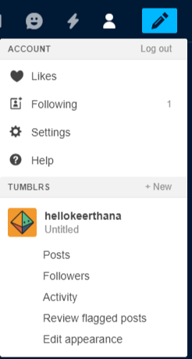

1. Click the **Edit Theme** button.

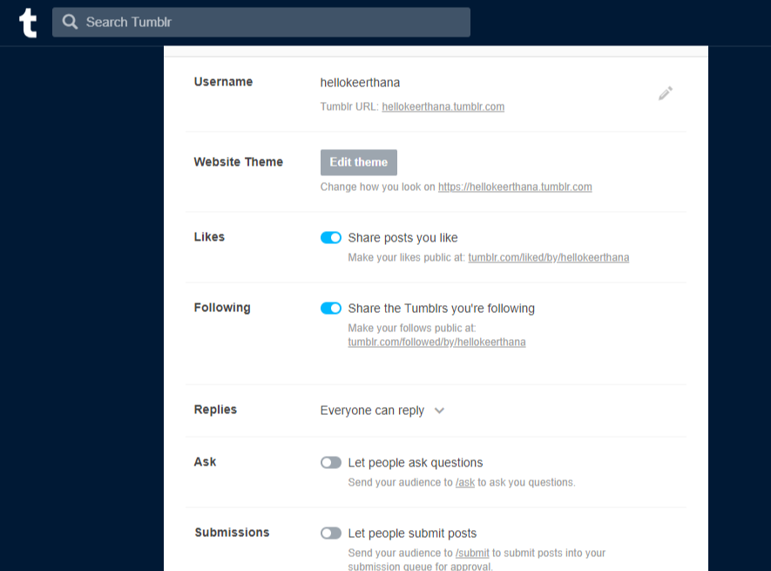

Click the **Edit HTML** link to reveal your blog's source code.

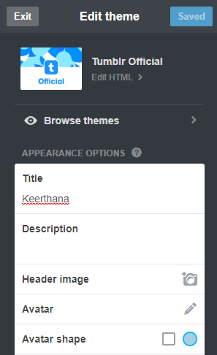

1. Paste the HTML code snippet supplied by the ad platform into your blog's source code at the place where you want the ad to appear. Click the **Update Preview** button and use the preview pane to check whether your ad displays correctly.

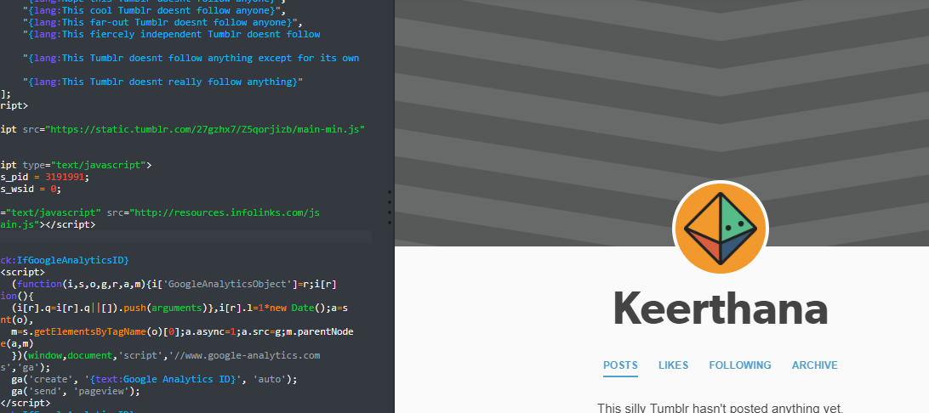

1. Click the **Save** button to save and publish your changes.